## Lab 2 Report

### Main Idea

In this lab, I have developed a simple in-store coffee ordering app. Users visiting a cafe called *“The Lazy Bean”* can use this app to place an order for a coffee, and wait for it to be ready, till the cafe employees call the user’s name. The app initially records name and email id of the user, allows the user to select a coffee from a menu and review it and place an order, view the receipt, as well as view last 3 orders made by the user. The app stores all the orders in an SQLite database, placed by the, identified by user’s unique email id.

### Implementation

I have created one activity for each of the 4 main screens of the app - Main screen, Menu screen, Review Order screen and Receipt screen.

**Main screen**

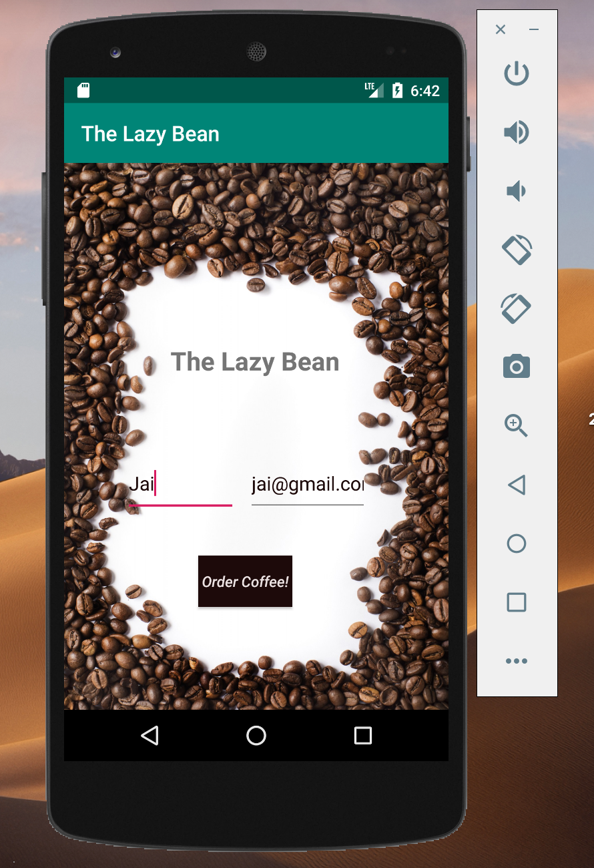

**Menu Screen**

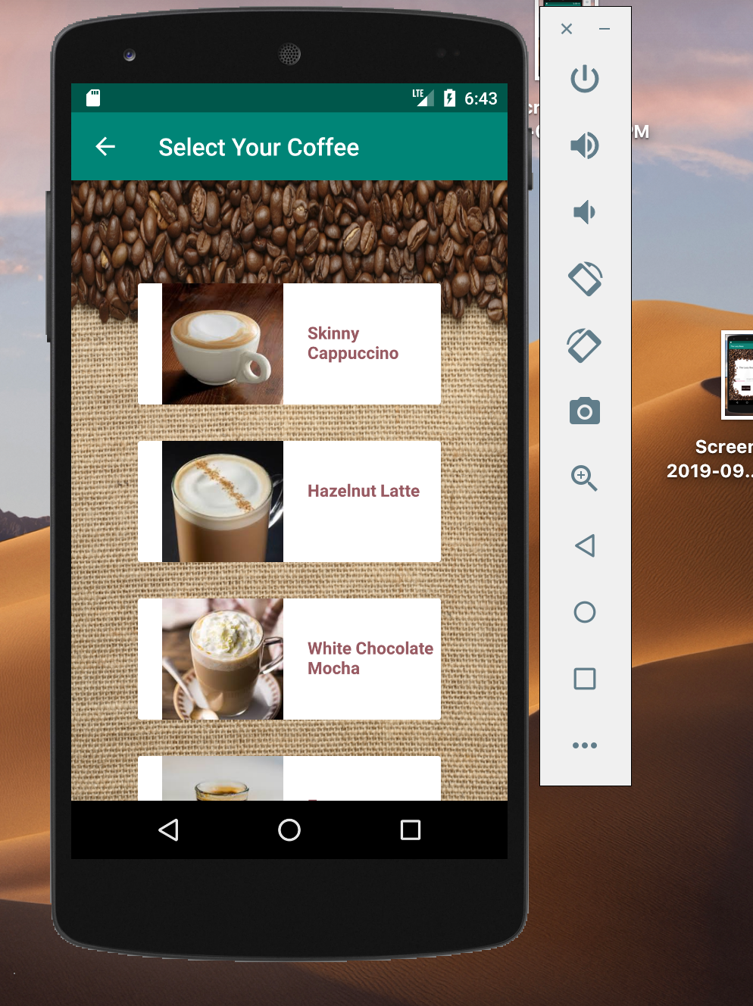

**Review Order**

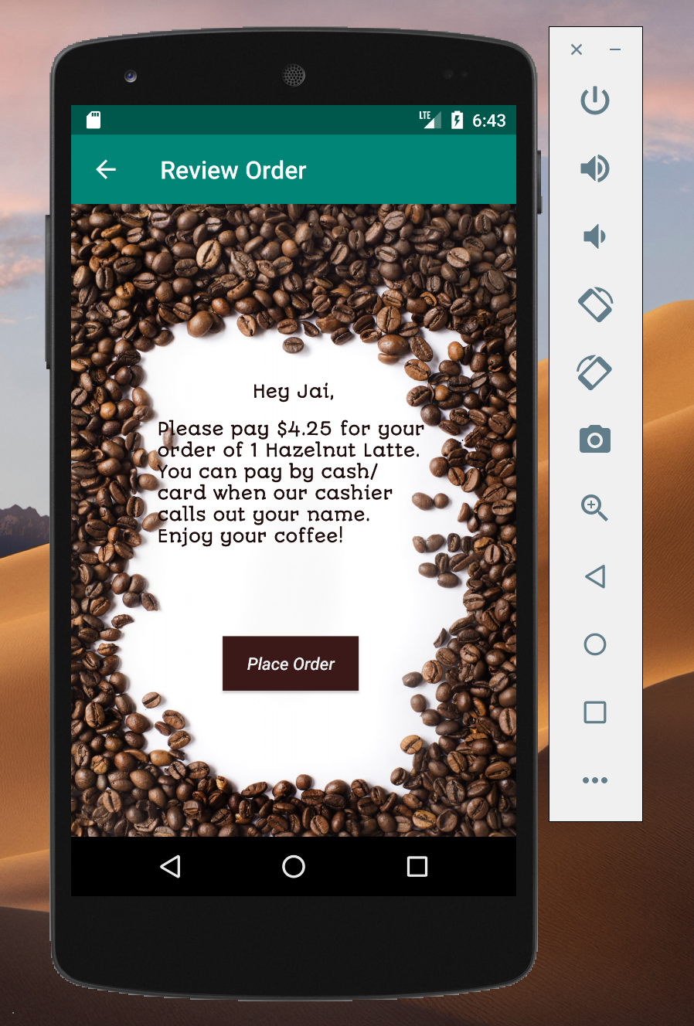

**Receipt Screen**

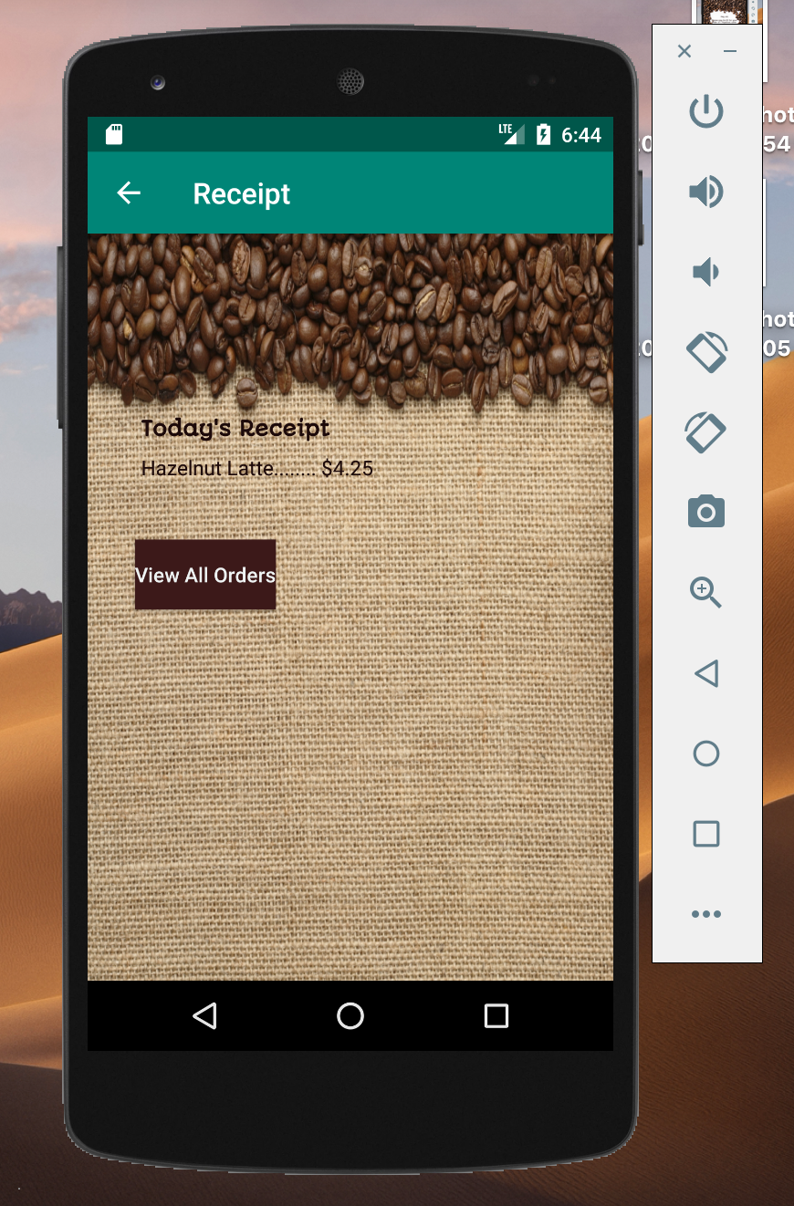

For the last screen, I have created a fragment for viewing the last 3 orders placed by the user, which gets attached to the ReceiptActivity

**Last 3 Orders**

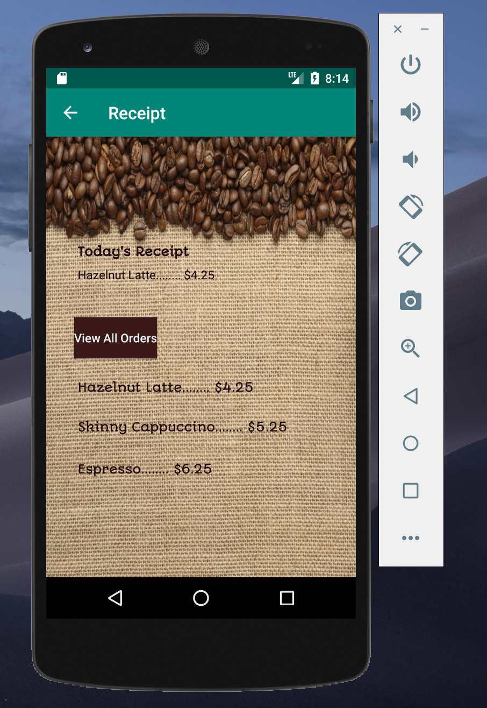

Throughout the app’s workflow, activities are started using explicit intent, and data such as name, email id, selected coffee is passed to the necessary activity as a part of the intent. The passed data can be viewed on the Review Order screen and Receipt screen.

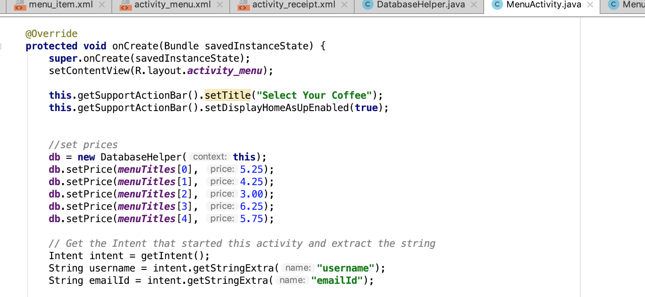

A dialog appears after the user places an order, to inform about current offers

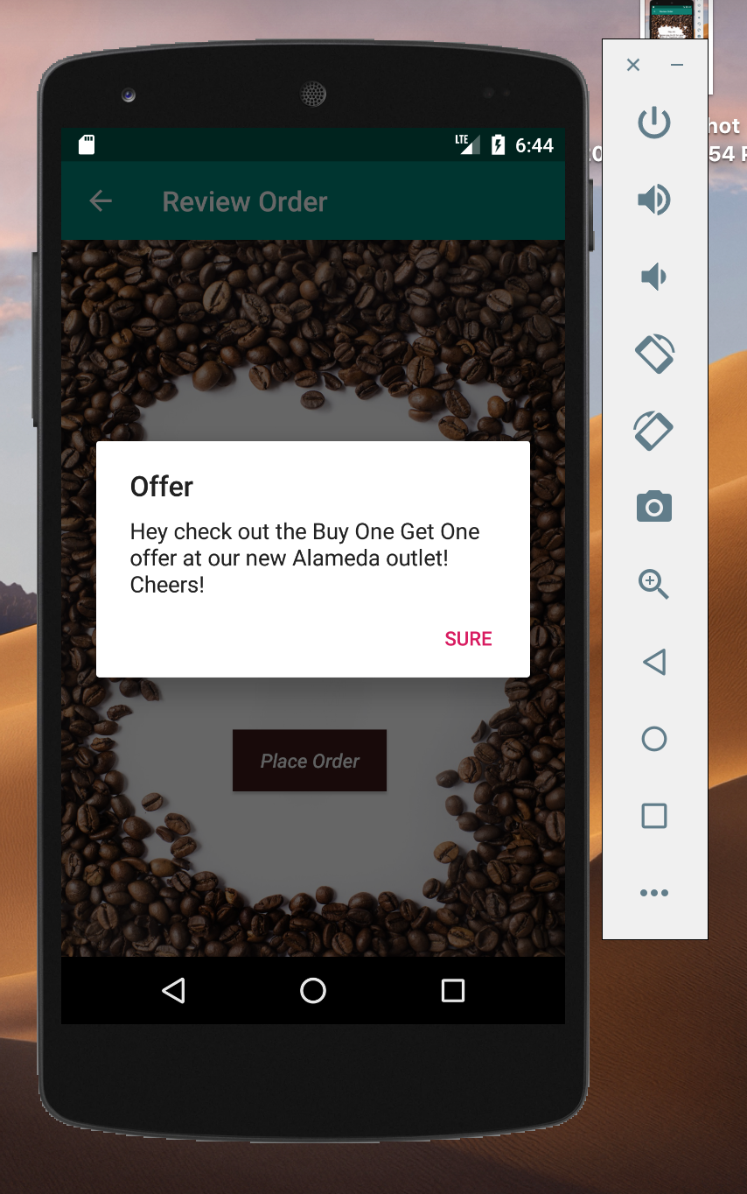

Toast messages appear when user tries to start ordering without entering details, and when the order is placed.

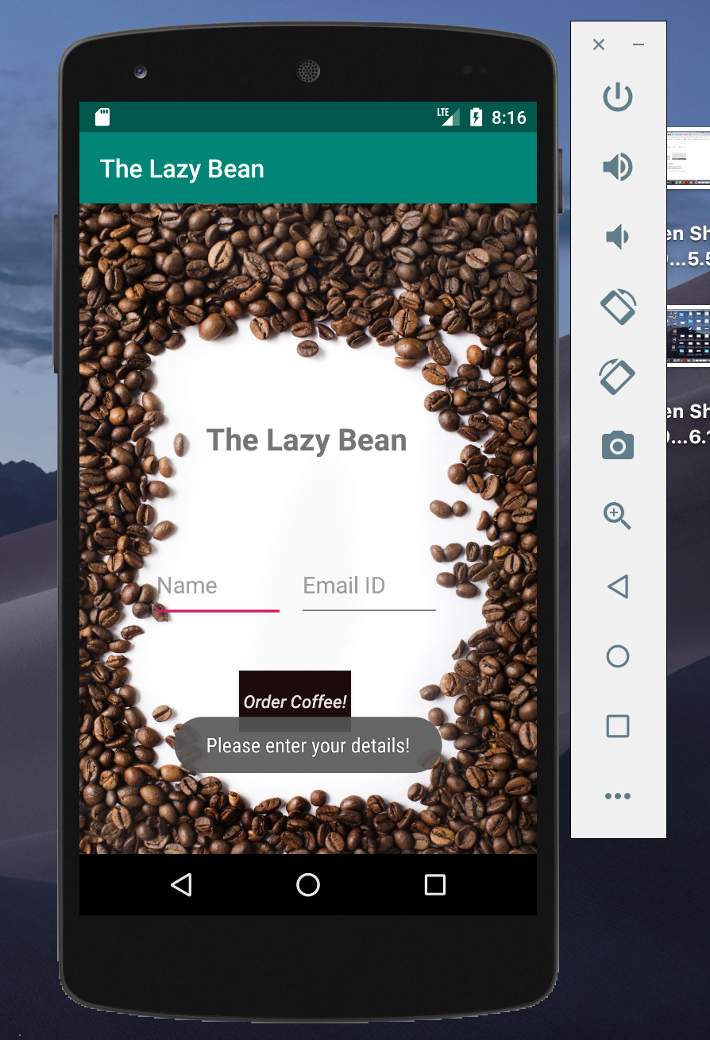

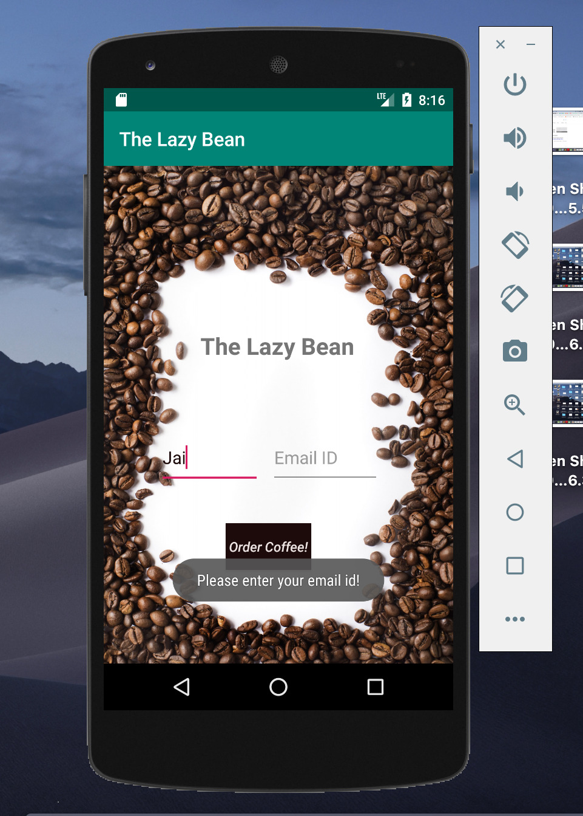

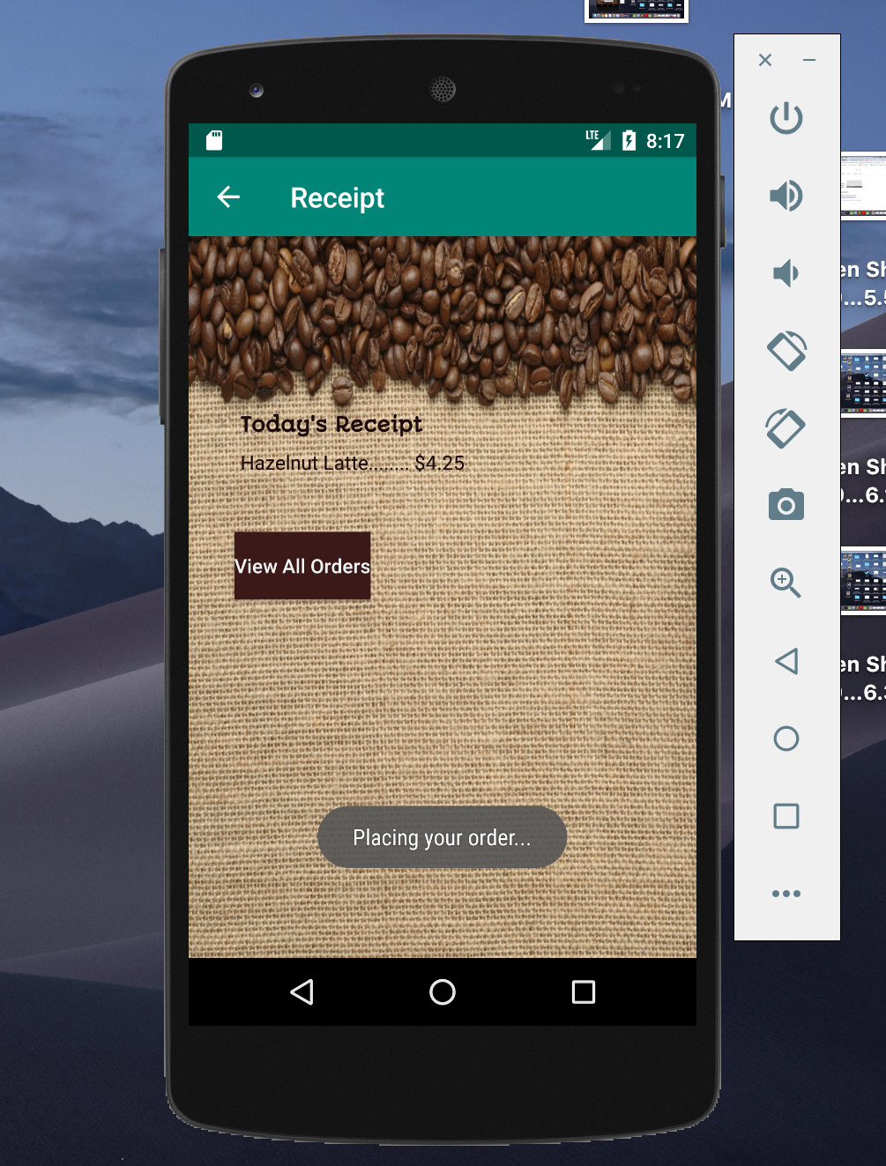

The Action Bar helps the user to know their location in the app, the back arrow helps user to navigate to the appropriate previous screen.

The Sqlite database has two tables- one for storing cost of various coffees, and second one for storing all the placed orders (with email id being the primary key). Coffee rates are stored at the start of the MainActivity of the app, while placed order is stored after user confirms the order. This stored information is read on the Payment as well as Receipt screen.

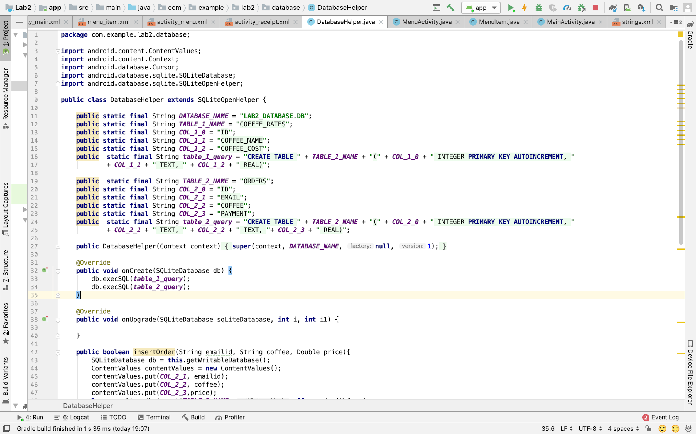

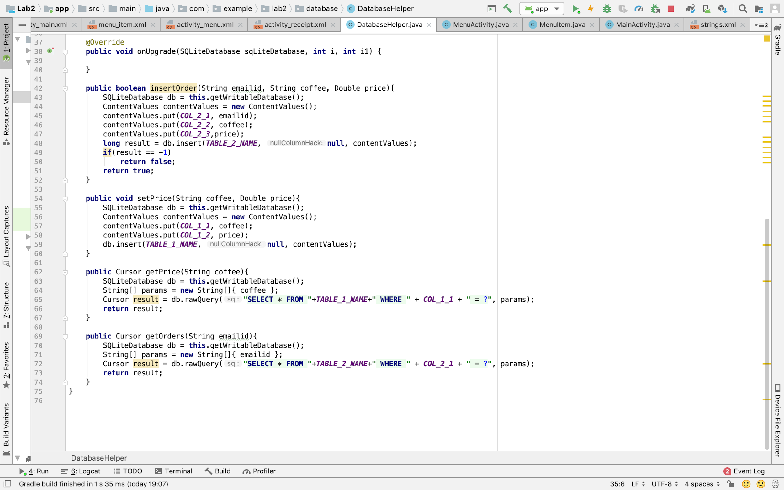

### Summary

I have implemented all the UI elements - TextView, Buttons, Dialog, Toast Notifications, ActionBar along with RecyclerView and CardView. Tota 4 Activities and 1 Fragment, alongwith the Sqlite database have been implemented. Explicit intents have been used to start activities and pass data amongst activities

### Android Profiler Screenshots

